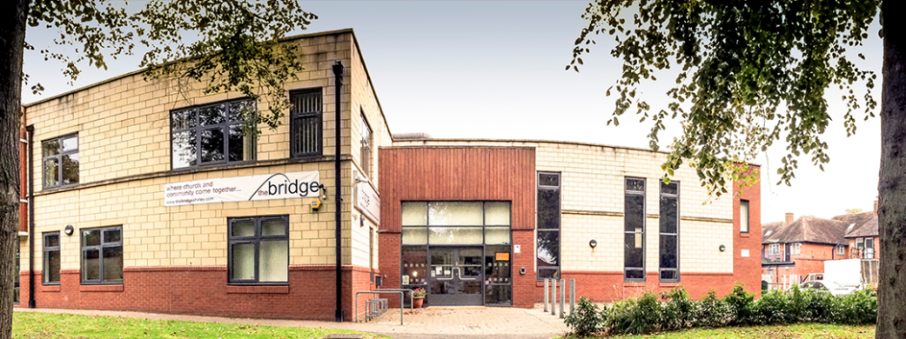

Sunday 14th August
Hot Drinks: 10:15
Gathering: 10:45
Welcome to our Sunday Service. Come expecting to encounter God through worship and word as we bring ourselves to him.
Sally will be continuing our theme on Psalms, covering Psalm 91. Andrea is hosting.

Wednesday 10:45
This week, we welcome Bernice Pannell who has been a missionary in Ecuador and a teacher at All Nations Bible College. Do come and listen to her as she shares her walk with the Lord.

Writing a Psalm
Last Sunday, Craig shared on Psalms of Lament. For those of you who would value writing your own Psalm, here is a Lament Writing Exercise with a suggested structure based on various Psalms. You could do this on your own on within your small group or triplet. Email enquiries@thebridgeshirley.com if you would like a copy.

Volunteers At The Bridge
We are asking for some people to help around the Bridge. Some staff are on holiday and we would appreciate cover for some roles, along with weeding outside, trimming the hedge, and caretaking events. Amalie and Sam have already given of their time and energy. If anyone else can help out over the next few weeks, it would be very much appreciated. Please email enquiries@thebridgeshirley.com if you think you can help. Many thanks!

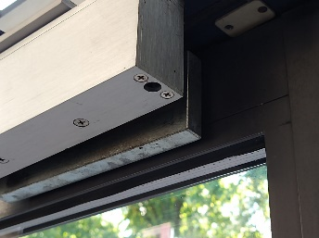
Door Catch
When using the front door, please can you check that the magnet catches when you close it behind you. It occasionally bounces back slightly. This should help keep the building secure. Many thanks.

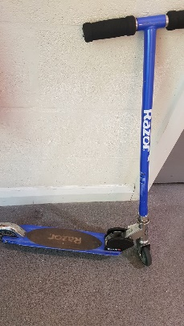
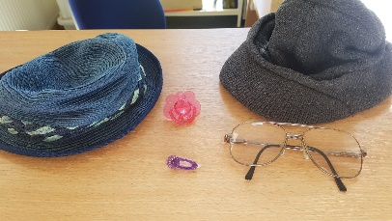
Lost Property
A number of items have been left since the weekend away, including a phone charger. If they are not claimed soon, I will take them to the charity shop. Please collect by Sunday or let me know to hold onto them for you.

Kids Eat for £1
The link below could be helpful if you’ve got children to feed over the summer holidays. The offer is available for children up to age 16 to have a hot meal for £1 with no minimum adult spend.
https://corporate.asda.com/newsroom/2022/07/05/children-can-eat-for-just-1-at-asda-cafes-across-england-and-wales-this-summer-with-no-minimum-adult-spend

BTG+
Bridging the Gap Plus will be on a RETREAT this Saturday. We usually meet every 2nd Saturday of the month in the lounge, but as it's holiday season we will be away too.

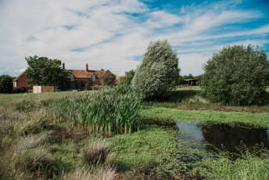
We are retreating to Redhill, a Christian Retreat Centre in Warwickshire. They have overnight en-suite rooms and camping facilities if you want to stay longer. Click on the pictures for more details.

Bible Study
Tuesday Mornings

A group to discuss and study the Bible. All welcome.

BTG

Bridging the Gap will continue to meet every Tuesday morning during the summer. Please email for details if you wish to attend.

Transport Request
Is someone available to help a member get to Birmingham Airport for 5pm on Friday 19th August please, also, 26th August at 5:30 pm, returning 2nd September at about 8pm? Please email enquiries@thebridgeshirley.com if you have transport and are available. Many thanks.

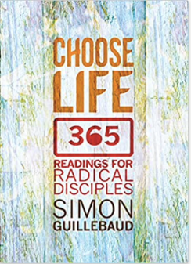
Yearly Devotion
Choose Life
As a church, we are doing this daily devotion. It is released on YouTube every Friday. Subscribe to SCF Media to view and keep up to date. You can also watch Simon's latest podcast: https://www.simonguillebaud.com/inspired-podcast/, and his vlog: https://www.greatlakesoutreach.org/people/simon-guillebaud/choose-life/

Employment Opportunity
Children's Worker birth - reception
We are looking to recruit a Children's Worker for our babies, preschool, and nursery aged children.
Are you passionate about working with babies and young children? Do you feel rewarded by helping them connect with God? Then email enquiries@thebridgeshirley.com for more information, a job description, and an application form.

Parents/Guardians of Children & Youth
We wanted to direct all parents/guardians that we are in contact with here at SCF to some helpful websites and resources around keeping children and young people safe online.
Please check out the following links - there is some really helpful information including downloads and practical guides.
https://saferinternet.org.uk/guide-and-resource/parents-and-carers
https://www.childnet.com/parents-and-carers/have-a-conversation/
https://www.nspcc.org.uk/keeping-children-safe/online-safety/

We are grateful to everyone who gives to the work of the church. If you feel you should alter your giving, our account details are:
Bank Account Name: Solihull Christian Fellowship, Sort: 30-97-57, A/C: 02041678.
We have a PayPal account too: PayPal.Me/thebridgeshirley.
If cheques are easier for you, then either drop them in the post or we’d love to see you in person at The Bridge.
