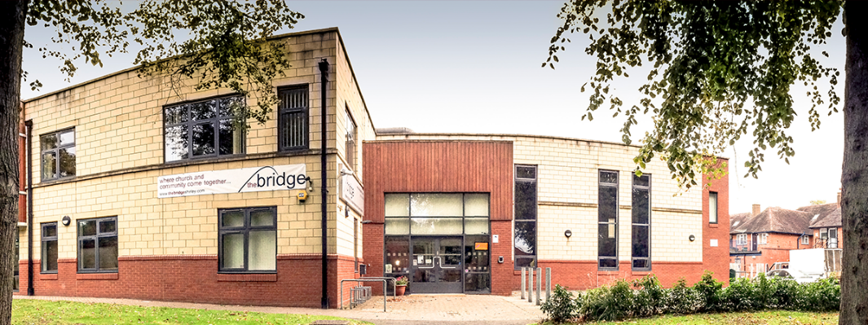

Sunday 29th May
Hot Drinks: 10:15
Gathering Starts: 10:45
Sally is hosting our gathering and Ben is bringing God's word. The service will also be live streamed on SCF-Media.

LAH
Wednesday 10:45
Our speaker this week will be Andrea Lowndes, who will also be leading us in Communion. Do come along and share fellowship with one another. Tea and coffee will be served from 10.45am.

Half Term
Please note, it is half term next week, so a number of our usual groups may not be meeting.

Alpha Course:
Zoom Prayer Monday
Course Thursday
Prayer during course Thursday
Covering Alpha With Prayer
Mondays 7:00-7:40pm
On Monday, you are welcome to join us for a zoom prayer session for the Alpha course. Click the zoom link here or use the meeting id and passcode once on zoom:
Meeting ID: 771 3447 2676 Passcode: Alphapray
Thursdays 7:00-9:00pm
As this is such a life-changing course, we are expecting the enemy to attack, so please join a small group in praying during our sessions too. Email enquiries@thebridgeshirley.com to be linked in.

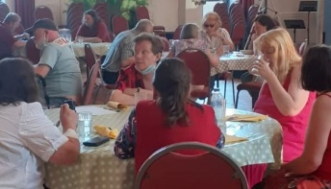
Community Lunch
Wednesday Lunchtime
Come and share food with our local community. Lunch is served from 12-1:30pm.
Jubilee Tea on The Terrace, Saturday 4th June
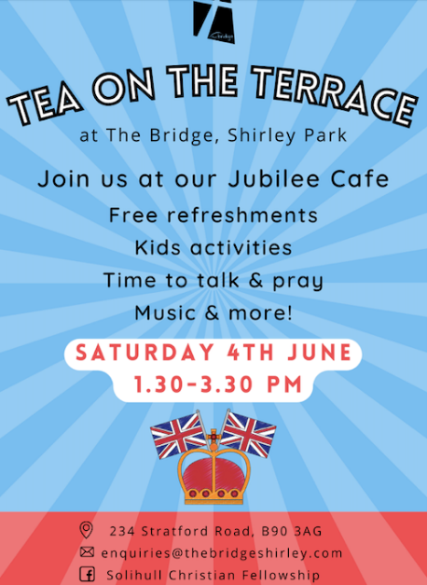
The Jubilee weekend will soon be upon us and I am sure you are looking forward to having a few extra days off. There will be lots of activities going on in Shirley Park over this extended weekend, starting on Thursday and running through to Saturday. Friends of Shirley Park have asked us to run café on Saturday 4th June.
How Can You Help
You know the pattern now for our Tea on The Terrace. Drinks, a few biscuits, crafts, games, and good conversation. We need your help Saturday 4th 13:30–15:30. If you can come and support this in any way, for the whole 2 hours or just for part of it, we would really appreciate it. Please let us know if you can help by emailing enquiries@thebridgeshirley.com or by signing up in the foyer.
An Opportunity for The Gospel
There will be lots going on in the park so we expect it to be full. This is a great opportunity to talk about who we are, and why our faith is important to us. The Queen has a faith in Jesus which is often evident through her public engagements, but particularly at Christmas when we all settle down to listen to her on Christmas Day. What an opportunity to share the gospel when conversation is about the Queen and her life. It is easy to speak about her faith and to speak about our faith too.
Sunday 5th June
There will be various events going on in and around Shirley Park on Sunday. It’s also our picnic week. What a great opportunity to picnic together as a church out on the terrace.

Tuesday Club Platinum Jubilee Tea Party
Tuesday June 7th, 2-4pm.
The Tuesday Club is run for the more senior members of the church, where we enjoy tea, coffee, and cake; do a Quiz; play Rummikub and Scrabble; and discuss Christian issues in the Bible. For the Platinum Jubilee Tea Party, we shall enjoy cake and refreshments and focus on the faithful service our Queen has given to this country during the past 70 years. Do come along to this special occasion, whatever your age, and share any memories you might have of the coronation or other royal events.

Bereavement Group
Starting Wednesday 8th June
A group for those having suffered loss, following the Care for the Family course.

Caleb Freedom Course

Saturday 11 June
Martin Allen from Caleb Ministries is joining us to run this one day course aimed at helping Christians who struggle to escape a negative mindset that ensnares them; adversely affecting their relationships. The day comprises of teaching sessions, interactive discussion, and examines the cause and root of these issues. Scheduled 1:1 in-depth ministry sessions will also be offered.

Weekend Away July 1st -3rd
We’re all looking forward to a really enjoyable, inspiring, and uplifting weekend together as the SCF Church Family. If you haven’t booked yet, then there’s still time - download a form from our website, drop an email to bookings@thebridgeshirley.com, or call the Church Office 0300 561 0300.

For those who have booked, you should have received an email asking you to make your meal choices & to let us know about any dietary requirements. It’s very easy to do, so please respond as quickly as you’re able. There will also be forms available on Sundays for those who would prefer.

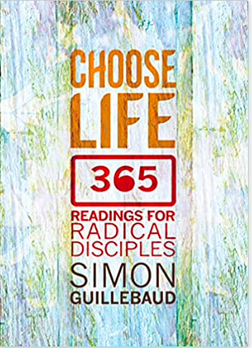

Yearly Devotion
Choose Life
Still giving these your best shot? Don't forget Simon's latest podcast: https://www.simonguillebaud.com/inspired-podcast/, and his vlog: https://www.greatlakesoutreach.org/people/simon-guillebaud/choose-life/.

For Sale
Eton Recliner Chair, hardly used £500, like new. Click on picture for specifications, and email steve.cordon@thebridgeshirley.com if interested.

Free Electrics
Please email enquiries@thebridgeshirley.com if you can make use of any of these items pictured. Thanks!

Free Boxes
We have been given a box of boxes - sturdy and strong enough to contain a book for posting, for example. Approx. 23cmx18cm with lids. Email enquiries@thebridgeshirley.com if you can use them.

We are grateful to everyone who gives to the work of the church. If you feel you should alter your giving, our account details are:
Bank Account Name: Solihull Christian Fellowship, Sort: 30-97-57, A/C: 02041678.
We have a PayPal account too: PayPal.Me/thebridgeshirley.
If cheques are easier for you, then either drop them in the post or we’d love to see you in person at The Bridge.
