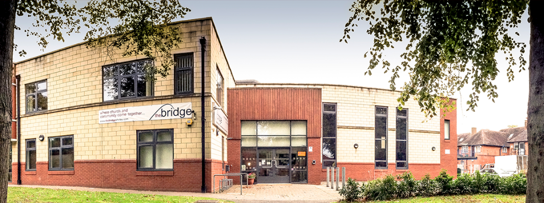Sunday 22nd May
Hot Drinks: 10:15
Gathering Starts: 10:45
Steve is hosting our gathering and Andrea is bringing God's word. The service will also be live streamed on SCF-Media.

LAH
Wednesday 10:45am
This week, we welcome Paul Olise of Birmingham City Mission, who will tell us about the work of BCM and his own personal walk with Jesus. Do come along and enjoy fellowship with one another. Tea and coffee will be served from 10.45am.

Home Group Training
Saturday 21st 9:30-3pm
This is the first of our Home Group Training for group leaders. We plan to cover:
- The Purpose of homegroups
- The Role of the leaders
- How to engage your group
- Encouraging Spiritual Growth
- Accountability & Fellowship.

SEND Supporters Coffee & Chat Sunday 22nd PM
Lorraine and Dean Mills will be facilitating an informal gathering in the Lounge straight after our gathering for families with children with SEND/an EHCP, adults with additional needs or disabilities, and any carers. It'll be a great opportunity to chat with others who understand our challenges and offer one another help, advice, and prayer.
Anyone who works in the world of SEND is also very welcome to attend. Refreshments will be provided and some toys will be out for the children. Feel free to bring a picnic!

Alpha Course
Zoom Prayer Monday
Course starts Thursday
Prayer Thursday
Covering Alpha With Prayer
Mondays 7:00-7:40pm
On Monday you are welcome to join us for a zoom prayer session for the Alpha course. Use the meeting id and passcode once on zoom:
Meeting ID: 771 3447 2676 Passcode: Alphapray
Thursdays 7:00-9:00pm
As this is such a life-changing course, we are expecting the enemy to attack, so please join a small group in praying during our sessions too. Email enquiries@thebridgeshirley.com to be linked in.
Jubilee Tea on The Terrace, Saturday 4th June
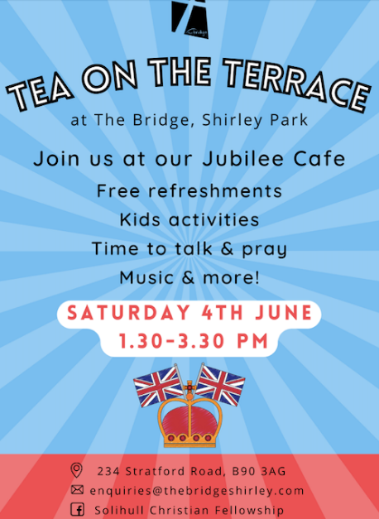
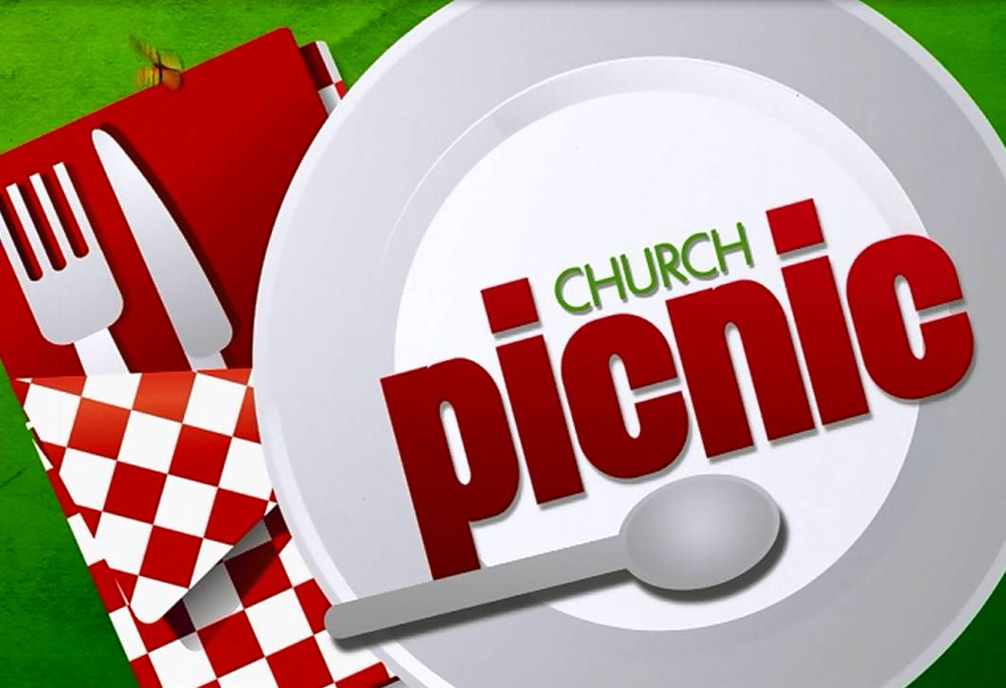
The Jubilee weekend will soon be upon us and I am sure you are looking forward to having a few extra days off. There will be lots of activities going on in Shirley Park over this extended weekend, starting on Thursday and running through to Saturday. Friends of Shirley Park have asked us to run café on Saturday 4th June.
How Can You Help
You know the pattern now for our Tea on The Terrace. Drinks, a few biscuits, crafts, games, and good conversation. We need your help Saturday 4th 13:30–15:30. If you can come and support this in any way, for the whole 2 hours or just for part of it, we would really appreciate it. Then please let us know by emailing enquiries@thebridgeshirley.com or by signing up in the foyer.
An Opportunity for The Gospel
There will be lots going on in the park so we expect it to be full. This is a great opportunity to talk about who we are, and why our faith is important to us. The Queen has a faith in Jesus which is often evident through her public engagements, but particularly at Christmas when we all settle down to listen to her on Christmas Day. What an opportunity to share the gospel when conversation is about the Queen and her life. It is easy to speak about her faith and to speak about our faith too.
Sunday 5th June
There will be various events going on in and around Shirley Park on Sunday. It’s also our picnic week. What a great opportunity to picnic together as a church out on the terrace.

Caleb Freedom Course
Saturday 11 June
Martin Allen from Caleb Ministries is joining us to run this one day course aimed at helping Christians who struggle to escape a negative mindset that ensnares them; adversely affecting their relationships. The day comprises of teaching sessions, interactive discussion, and examines the cause and root of these issues. Scheduled 1:1 in-depth ministry sessions will also be offered.

Weekend Away July 1st -3rd
We’re all looking forward to a really enjoyable, inspiring, and uplifting weekend together as the SCF Church Family. If you haven’t booked yet, then there’s still time - download a form from our website, or drop an email to bookings@thebridgeshirley.com or call the Church Office 0300 561 0300.
For those who have booked, you should have received an email asking you to make your meal choices & to let us know about any dietary requirements. It’s very easy to do, so please respond as quickly as you’re able. There will also be forms available on Sundays for those who would prefer.

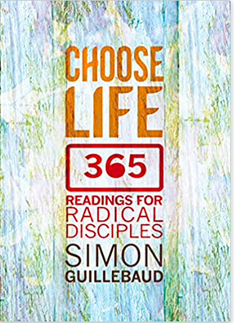
Yearly Devotion
Choose Life
As a church, we are doing this daily devotion. You can listen to our own weekly reflection by going to SCF Media on YouTube.
You can also watch Simon's latest vlog or podcast

Circus Vegas
We have been given some vouchers for Circus Vegas, showing at the NEC, from Friday 20th May - Sunday 5th June. Click the picture for more details. Limited number of vouchers are available on the reception desk.

We are grateful to everyone who gives to the work of the church. If you feel you should alter your giving, our account details are:
Name: Solihull Christian Fellowship, Sort: 30-97-57, A/C: 02041678.
We have a PayPal account too: PayPal.Me/thebridgeshirley.
If cheques are easier for you, then either drop them in the post or we would love to see you in person at The Bridge.

